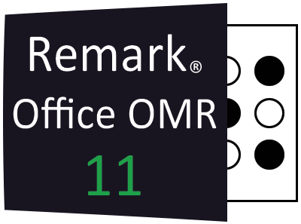
Remark Office OMR 11.2
New Features and Enhancements
June 2023

- indicates customer request

Fixes:

- Change Log Updates: Changes to the data grid are now recorded in the change log regardless of whether the recovery log is enabled.
Boolean Regions: An issue was fixed where Boolean region labels were reset when updating the column and row properties of the template.
Optimization Update: We fixed an issue where the Changed Answer reports still displayed when software optimization is set to disable response statistic calculations.
- Point Biserial Calculation with Add Regions: A problem was fixed where the point biserial calculation was not correct for Add regions.
- 5800 Error Running 104 Student Histogram Report: A 5800 error was corrected when running the Student Histogram Report with floating correct point values.

Features and Enhancements:

- Accessibility: The entire product was reviewed for accessibility and updated accordingly to provide a better experience for users with disabilities.
- Student Pretest - Posttest Report: A Student Pretest-Posttest report was added to compare results from a pretest and a posttest.
- Student Achievement Report: You no longer have to set up a benchmark to run the Student Achievement Report. Ensure that the “Include Students” property is set to “All Students” if you are not using a benchmark.
- Customizing Report Labels: The ability to customize the “Learning Objectives” and “Description” labels was added to the 111 - Class Learning Objectives Report.
- Copy and Paste for Partial Credit: You can now copy and paste in the grid used to set up partial credit in an answer key.
- Report Style Properties: For any report style property that allows you to edit the text (e.g. Footer text) you will now see a pencil you can click to edit the default text.
- Schema Names: We added the schema name when using SQL Server and ODBC connections. You will now see the schema name pre-pended to the table name when using Database Lookup, opening data, saving data and appending data to existing files.
- Cronbach Alpha Update: Report preferences were added to the 100 - Test Analysis Report so that you can change the scale item names and ranges used for the Cronbach Alpha score.
- Reviewed Exception Type: An exception type was added for “Reviewed” cells to let you know which cells had already been reviewed while using Review Exceptions.
- Read from Folder: You can now read an entire folder’s worth of images when processing your form. Use the “Add Folder” button in the Read window to select a folder. You can also filter the image type so that Remark only looks for specific images.
- Image Base Names: When using the Package and Rename feature you can now add a field called [Image Name] that allows you to use the original image file name in the new name of the packaged image.

Copyright © 2023 Gravic, Inc. All Rights Reserved. Remark, Remark Office OMR and Remark Quick Stats are registered trademarks of Gravic, Inc. All other products mentioned are trademarks of their respective holders. Specifications subject to change without notice.

