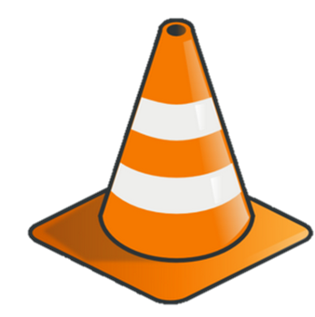
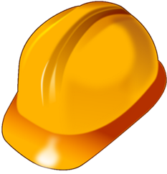
RMK Corp

Safety Observation
Mark one:
1 | Drilling | 4 | Completion
2 | Construction | 5 | Distribution
3 | Production | 6 | Other
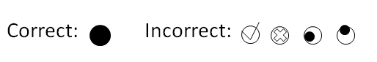
Observation Date
Month |  | Day |  | Year
0 | 0 | 0 | 0 | 0 | 0 | 0 | 0
1 | 1 | 1 | 1 | 1 | 1 | 1 | 1
 | 2 | 2 | 2 | 2 | 2 | 2 | 2
 | 3 | 3 | 3 | 3 | 3 | 3 | 3
 | 4 |  | 4 | 4 | 4 | 4 | 4
 | 5 |  | 5 | 5 | 5 | 5 | 5
 | 6 |  | 6 | 6 | 6 | 6 | 6
 | 7 |  | 7 | 7 | 7 | 7 | 7
 | 8 |  | 8 | 8 | 8 | 8 | 8
 | 9 |  | 9 | 9 | 9 | 9 | 9
Observer ID
0 | 0 | 0 | 0 | 0 | 0 | 0
1 | 1 | 1 | 1 | 1 | 1 | 1
2 | 2 | 2 | 2 | 2 | 2 | 2
3 | 3 | 3 | 3 | 3 | 3 | 3
4 | 4 | 4 | 4 | 4 | 4 | 4
5 | 5 | 5 | 5 | 5 | 5 | 5
6 | 6 | 6 | 6 | 6 | 6 | 6
7 | 7 | 7 | 7 | 7 | 7 | 7
8 | 8 | 8 | 8 | 8 | 8 | 8
9 | 9 | 9 | 9 | 9 | 9 | 9

Body Positions | Safe | At Risk
1.1 Pinch Points | O | O
1.2 Line of Fire | O | O
1.3 Ascending/Descending | O | O
1.4 Eyes on Path/Work | O | O
1.5 Bending/Lifting | O | O

PPE | Safe | At Risk
2.1 Head | O | O
2.2 Hearing | O | O
2.3 Feet | O | O
2.4 Falling Protection | O | O
2.5 Eyes/Face | O | O
2.6 Hands | O | O
2.7 PFD/Work Vest | O | O
2.8 Respirator | O | O

Procedures/Operations | Safe | At Risk
3.1 Job Planning | O | O
3.2 Barriers/Signs | O | O
3.3 Crane | O | O
3.4 Tools/Equipment | O | O
3.5 Helicopter Operations | O | O
3.6 Lockout/Tagout | O | O
3.7 Housekeeping | O | O
3.8 Boat Operations | O | O
3.9 Rigging | O | O

Driving | Safe | At Risk
4.1 Aim High in Steering | O | O
4.2 Keep Your Eyes Moving | O | O
4.3 You Are Seen | O | O
4.4 Get the Big Picture | O | O
4.5 Leave Yourself an Out | O | O

Comments

