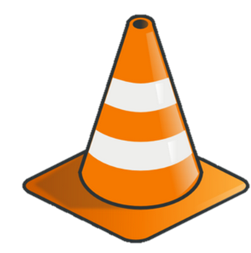
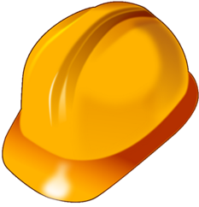
RMK Corp

Safety Assessment
This assessment measures the safety performance of your construction team. With continual efforts to improve, please read each item and then fill in the bubble that best indicate your level of agreement.
Safety Planning and Management | Strongly Agree | Agree | Neutral | Disagree | Strongly Disagree
- The safety goals for our team relates to many things, not just injury rates. |  |  |  |  | 
- Outside sources are used to establish performance standards and goals. |  |  |  |  | 
- We have a safety committee with broad authority. |  |  |  |  | 
- Employees are aware of the rewards and consequences for poor or exceptional safety performance. |  |  |  |  | 
- Health and safety is understood to be part of an employee’s job responsibilities. |  |  |  |  | 

Safety Planning and Management Comments:

Safety Standards and Practices | Strongly Agree | Agree | Neutral | Disagree | Strongly Disagree
- Safety rules are up to date. |  |  |  |  | 
- In compliance with OSHA standards. |  |  |  |  | 
- Safety standards are well understood. |  |  |  |  | 
- Equipment and safety items are inspected regularly. |  |  |  |  | 
10. Inspection records are well maintained. |  |  |  |  | 
11. Safety rules are enforced. |  |  |  |  | 

Safety Standards and Practices Comments:

